**IOT BASED INTELLIGENT/SMART TRAFFIC MANAGEMENT FOR AMBULANCE**

**Abstract**

The accretion of traffic has led to the use of more sophisticated Traffic management system in today's society. Traffic Congestion is a major factor which forestalls the smooth flow of Ambulance vehicles. To abate the inconvenience caused by the traffic, the Traffic Light Controller (TLC) is used which minimizes the waiting time of vehicle and also manages traffic load. RFID based systems play a crucial role in solving the problems caused by traffic. The project is a replica of a four-way lane crossing of real time scenario. In the first part, concentrated on problems faced by Ambulances, RFID concept is used to make the Ambulance’s lane Green and thus provides a free way without interrupting the Ambulance. In the second part, concentrated on problems faced by Priority vehicles, IR sensors are used to actuate the timers accordingly and thus preventing traffic congestion. In the third part, concentrated on Traffic density control, IR transmitter and receiver are used to provide dynamic traffic control and thus increasing the duration of the Green light of the lane in which traffic density is high and hence, regulating traffic

**Introduction**

Traffic management on the road has become a severe problem of today's society because of growth of the urbanization, industrialization and population, there has been a tremendous growth in the traffic. With growth in traffic, there is occurrence of bundle of problems too; these problems include traffic jams, accidents and traffic rule violation at the heavy traffic signals. This in turn has an adverse effect on the economy of the country as well as the loss of lives.

Traffic lights play an important role in traffic management. Traffic lights are the signaling devices that are placed on the intersection points and used to control the flow of traffic on the road.

In 1868, the traffic lights only installed in London and today these have installed in most cities around the world. Most of the traffic lights around

the world follow a predetermined timing circuit. Sometime the vehicles on the red light side have to wait for green signal even though there is little

or no traffic. It results in the loss of valuable time. Traffic control at intersections is a matter of concern in large cities. Several attempts have been

made to make traffic light’s sequence dynamic so that these traffic lights operate according to the current volume of the traffic. Most of them use the

sensor to calculate current volume of traffic but this approach has the limitation that these techniques based on counting of the vehicles and

treats a emergency vehicles as the ordinary vehicles means no priority to ambulance, fire brigade or V.I.P vehicles. As a result, emergency vehicles stuck in traffic signal and waste their valuable time.

The problem of traffic light control can be solved by RFID based system.

The use of Embedded technology has proved to be very beneficial in present Traffic Light Controller (TLC) and that will minimize waiting time of vehicle and also manage traffic load. In this paper we exploit the emergence of new technology called as Intelligent traffic light controller, This makes the use of sensor n/w along with embedded technology. Where traffic light will be intelligently decided based on the total traffic on all adjacent roads. Thus optimization of traffic light switching increases road. Capacity, traffic flow and can prevent traffic congestions.

**Problem Definition (Exiting System)**

The problem of traffic light control can be solved by RFID based system. With this system, we can consider the priority of different type of vehicles and also consider the density of traffic on the roads by installing RF reader on the road intersections. The existing system has not these included the fetchers like checking the density of vehicle

**Overview**

The problem of traffic light control can be solved by RFID based system. With this system, we can consider the priority of different type of vehicles and also consider the density of traffic on the roads by installing RF reader on the road intersections. Radio frequency identification is a technique that uses the radio waves to identify the object uniquely. RFID is a technique that is widely used in the various application areas like medical science, commerce, security, Electronic toll collection system, access control etc. There are two main components of RFID: RFID tag and RF Reader. There are three kinds of RFID tags which work on the three different frequency ranges: low – frequency, high-frequency and ultra high frequency.

**Literature survey:**

Fixed cycle TLS tends to cause traffic congestion when one of the road bound have heavy traffic flow. Implementation of dynamic cycle TLS come into place to address this issue. However, collecting real-time traffic flow data for each road bound by traffic officer on the spot and alteration of GLPTs

manually afterwards are major challenges for local authority. In the worst case, traffic police are assigned to each road intersection, and the TLS is turned off for manual traffic flow control [9]. In order to address these issues, a network of sensors are installed on road intersection to monitor real-time traffic flow and alters these traffic lights automatically.

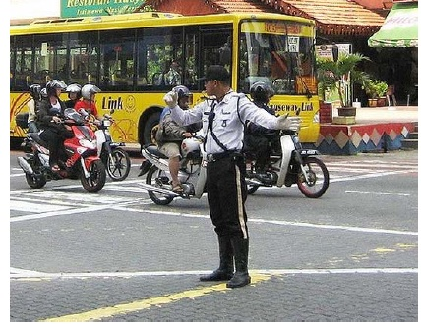

**Demo Points:**

* For demonstration purpose three roads are considered.
* In this prototype RFID reader used is of low frequency.
* Only road 2 is considered to be the route travelled, more frequently, by VIP vehicles and Ambulances.
* For demonstration purpose Wireless communication WIFI module is used for sending data to Amazon Cloud server.

**Block Diagram:**

Microcontroller

RFID Reader

LCD

5 IR Transmitters

5 IR Receivers along with Comparators

Power Supply

3 Traffic Poles with two LED’s (Red and Green)

GPRS

Server

**Layout**

**IR Rx IR Rx SRD3 IR Rx IR Rx**

**Road 2 Road 1**

**SRD1 SRD2 RFID IR Tx Road 3 IR Tx IR Tx**

**READER IR Tx IR Rx**

**SRD**x = Signal for Road x

**Description**

Many embedded systems have substantially different designs according to their functions and utilities. In this project design, structured modular design concept is adopted and the system is mainly composed of a single microcontroller, comparator, LED’s, RFID reader for communicating purpose we can use WIFI module.

The microcontroller located at the centre of the block diagram forms the control unit of the entire project. Embedded within the microcontroller is a program that helps the microcontroller to act based on the inputs provided by the output of the sensors.

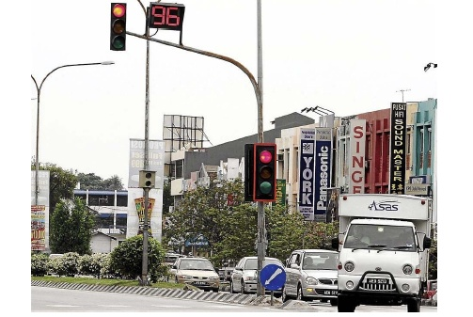

By default green signal will be activated for particular road for 5 seconds. Whenever the first IR receiver on a particular road is blocked, green signal will be displayed for 10 seconds. If the second IR receiver on a particular road is blocked, green signal will be displayed for 15 seconds. Whenever ambulance or VIP vehicle passes on a particular ( here road 2 for demo ), green signal will be displayed for 20 seconds. Wireless communication WIFI is used sending data to Amazon cloud server. All IR transmitter sensors communicate with IR receivers, on the opposite side of the road, in a line-of-sight propagation method. Every RFID tag has an Ten digit unique serial number. These RFID tags are mounted on the vehicle. Whenever the vehicle passes on Road 2, the RFID reader acquires the tag serial number through EM (Electro-Magnetic) waves. Embedded within the microcontroller is a database consisting the tag number of the particular vehicle. So whenever, an ambulance or VIP vehicle passes on Road 2, the serial number of the tag attached to there is acquired and the corresponding vehicle whether VIP or ambulance is displayed on LCD. To communicate with Intel Edison, IoT cloud server is chosen due to its compatibility and security. The cloud server have three layers of security protection: device security, connection security and cloud security. Each IoT device is assigned with unique identity key to enhance device security. The connection between IoT devices and cloud server is encrypted via WIFI Module.

In the above block diagram LCD is utilized to demonstrate the working of the entire unit.

**Architectural Diagram or System Architecture:**

ATmega328P  microcontroller from ATMEGA which is a 16-bit microcontroller is used to implement this project. Microcontroller acts as the heart of this project, which controls the whole system. It contains of Flash ROM 64KB, RAM 4KB and Data Flash 4KB, and it has High speed on-chip oscillator, Self-reprogrammable under software control, 58 GPIO’s, 3 UART’s, Simplified I2C, 10 bit resolution ADC, 28 Interrupt Sources, ISP programming support etc.

**Methodology**

Block Diagram

Hardware testing as per project

Test Code preparation for Peripherals

Logic Development as per project

Final Testing of the project as per Conditions

**Software’s:**

* Cube Suite+ Tool
* Arduino IDE
* Cayenne

**Hardware:**

* ATMEGA 328P
* RFID reader
* RFID tag
* 6 LED’s
* LM358 comparator
* 5 pair of IR transmitter and receiver
* LCD
* WIFI

**Advantages**

* It avoids problems that usually arise with present traffic control systems.
* This RFID technique deals with a multi-vehicle, multilane, multi road junction area.
* It provides an efficient time management scheme, in which a dynamic time schedule is worked out in real time for the passage of each traffic column.

**Disadvantages**

* System failure may occur due to tampering
* System failure may also take place in the absence of power to the entire unit attached to the vehicle.

**Future Scope:**

Going further, the details of the vehicle along with their RFID tag numbers can be stored on a centralized database. Cameras can be implemented in order to record driver’s sight line, while GPS can also be installed to detect the present location of the vehicle.

**REFRENCES**

[1] Rajat & Nirbhay Kumar (2014) “RFID Resolution: Your cars will be tagged”, The Economics Times, 25 September.

[2] Elisabeth ILIE-ZUDOR “The RFID Technology and Its Current Applications”, MITIP 2014

[3] Chong hua Li “Automatic Vehicle Identification System based on RFID”, Anti Counterfeiting Security and Identification in Communication (ASID), 2014